🖥️ Oxypc Desktop Refurbishment Application

📘 Overview
This Zoho Creator application manages the end-to-end refurbishment process for desktop systems at Oxypc. It automates each stage of the lifecycle — from Initial Quality Check (IQC) to Final QC, including GRN entry and multi-level repairs. At each stage, the system updates the central inventory with the current Stage and Status, ensuring real-time traceability and operational efficiency.

🔄 Desktop Refurbishment Flow

Stages:
- IQC
- GRN
- L1/L2 Repair
- L3/L4 Repair
- Final QC
- (Transfer to B2 – if required post-QC)

Flowchart:

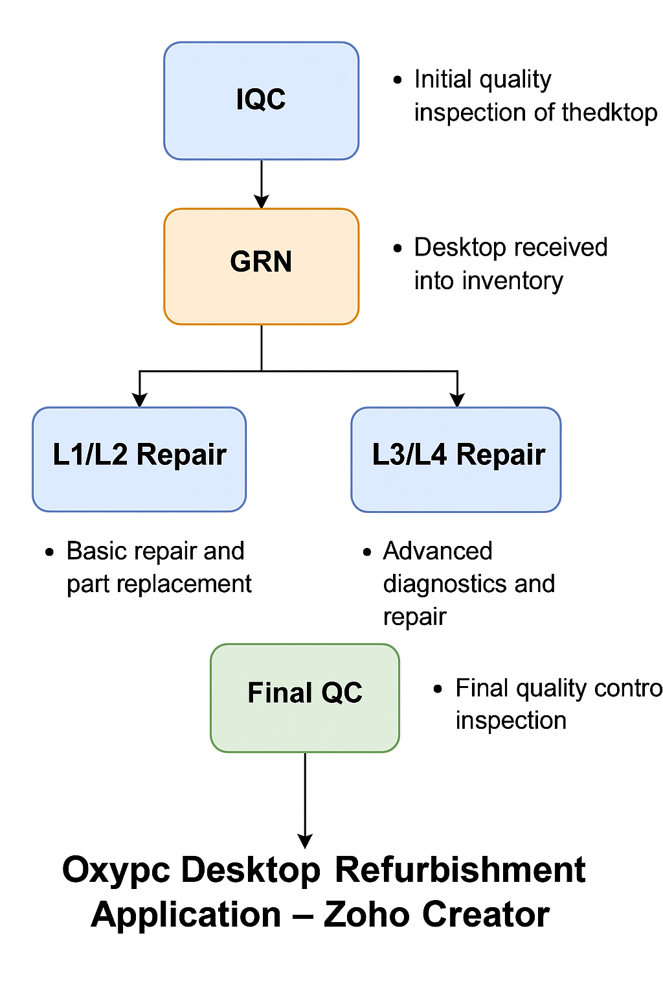

Form Documentation & Business Logic

1. IQC – Initial Quality Check
- Form Name: IQC Form - Desktop
- Purpose: Capture condition and basic diagnostic details for incoming desktops.
- Process:
- Visual inspection and fault logging.
- If no major issue found, mark as “Ready for Final QC”.
- Else, proceed to GRN stage.
- Deluge Logic:
Product_Stages = "Ready for Engineer Assignment"
Product_Status = "IQC Completed"

2. GRN – Goods Receipt Note
- Form Name: GRN
- Purpose: Log desktops that pass IQC into the warehouse system.
- Process:
  - Registered under a GRN number and location.
  - Tag numbers verified and logged.
- Deluge Logic:
Product_Stages = "Ready for Engineer Assignment"
Product_Status = "IQC Completed"

3. L1/L2 Repair
- Form Name: Desktop Repair
- Purpose: Handle basic repair and part replacements.
- Process:
  - Engineer assigned based on GRN.
  - Scan Tag Number → Fetch faults → Perform Repair.
  - If escalated, route to L3/L4.

- Deluge Logic:

if(Final_Status == "Completed") {
Product_Stages = "Ready for Final QC Assignment";
Product_Status = "Repair Completed";
}
else if(Final_Status == "Escalate to L4") {
Product_Stages = "Assigned to L3/L4";
Product_Status = "L4 Repair";
}
else if(Final_Status == "PNA") {
Product_Stages = "PNA(Part not available)";
Product_Status = "PNA";
}
else if(Final_Status == "Scrap") {
Product_Stages = "Scrap";
Product_Status = "Scrap";
}

4. L3/L4 Repair
- Form Name: L3/L4 Engineer Screen
- Purpose: Conduct deeper diagnostics and repair.
- Process:
  - Engineer performs motherboard, PSU, and NIC repair.
  - Logs remarks, component usage, and test results.
- Deluge Logic:
if(Final_Status == "Ok" && Received_From == "L1/L2 Engineer")
{
Product Stage="Assigned to L1/L2 Engineer";
Product Status="Repair";
}
else if(Final_Status == "Ok" && Received_From == "L4 Support")
{
Product Stage="L4 Support";
Product Status="Repair";
}
else if(Final_Status == "Scrap" && Received_From == "L1/L2 Engineer")
{
Product Stage="Scrap";
Product Status="Scrap";
}
else if(Final_Status == "Scrap" && Received_From == "L4 Support")
{
Product Stage="Scrap";
Product Status="Scrap";
}

5. Final QC
- Form Name: Final QC
- Purpose: Validate the functionality and cosmetic condition before dispatch.
- Process:
  - Auto-assigned if desktop passed IQC with no faults.
  - Final visual + performance checks.
- Deluge Logic:
if(Final_Status == "Pass")
{
Product_Master_Details.Product_Stages="Inventory Finalized";
Product_Master_Details.Product_Category="Finished Good";
}
if(Final_Status == "Fail" && Failure_Reason == "Functional")
{
Product_Master_Details.Product_Stages="Assigned to L1/L2 Engineer";
Product_Master_Details.Product_Category="Repair";
}

